Coursework Report Template for Module INM433 “Visual Analytics”

Author’s Name

Abstract—Put here a brief summary of your work: analysis task, data, approach, main findings. Length: up to 200 words.

Problem Statement

First paragraph...
Following paragraphs...
<250 words

State of the Art
First paragraph...
Following paragraphs...
<500 words

Properties of the Data
First paragraph...
Following paragraphs...
<500 words, <=2 images

Analysis

Approach
First paragraph...
Following paragraphs...
<500 words, 1 diagram
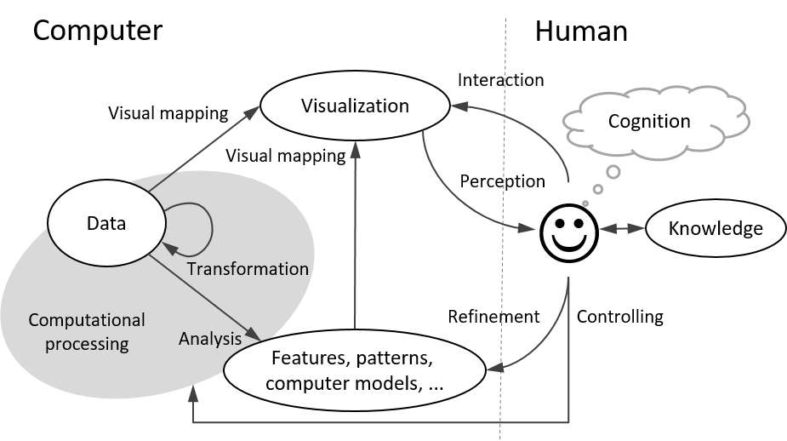
Fig. 1. An example of including a diagram in the document.

Process
First paragraph...
Following paragraphs...
<1500 words, <=7 images
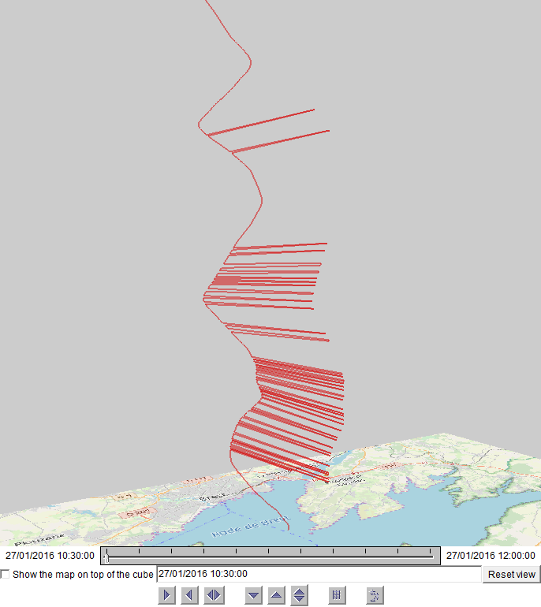
Fig. 2. An example of including a screenshot in the document.

Results
First paragraph...
Following paragraphs...
<200 words, <=2 images

Critical reflection
First paragraph...
Following paragraphs...
<500 words
Table of word counts
Problem statement | 250
State of the art | 500
Properties of the data | 500
Analysis: Approach | 500
Analysis: Process | 1500
Analysis: Results | 200
Critical reflection | 500

References
The list below provides examples of formatting references.

- M.Ankerst, M.Breunig, H.-P.Kriegel, J.Sander. OPTICS: Ordering points to identify the clustering structure. In: ACM SIGMOD 1999, pp. 49–60.
- M. Bögl, W. Aigner, P. Filzmoser, T. Lammarsch, S. Miksch, and A. Rind. Visual Analytics for Model Selection in Time Series Analysis, IEEE Trans. Visualization and Computer Graphics, 19(12): 2237-2246, 2013.
- T.F. Cox, M.A.A. Cox. Multidimensional Scaling. Chapman and Hall, 2001.
- S. van den Elzen and J.J. van Wijk. BaobabView: Interactive construction and analysis of decision trees, Proc. IEEE Conf. Visual Analytics Science and Technology (VAST’11), pp. 151-160, 2011.
- M.Harrower, C.A.Brewer: Colorbrewer.org: An online tool for selecting color schemes for maps. The Cartographic Journal 40(1): 27–37, 2003.
- T. Mühlbacher and H. Piringer. A Partition-Based Framework for Building and Validating Regression Models, IEEE Trans. Visualization and Computer Graphics, 19(12): 1962-1971, 2013.
- D. Phan, L. Xiao, R. Yeh, P. Hanrahan, T. Winograd. Flow map layout. In Proceedings of the IEEE Symposium on Information Visualization (InfoVis 2005), pp.219-224, Oct. 2005.
- J.W. Sammon. A nonlinear mapping for data structure analysis. IEEE Transactions on Computers, 18(5): 401–409, May 1969.
- J. Sewall, D. Wilkie, and M.C. Lin. Interactive Hybrid Simulation of Large-Scale Traffic, ACM Transactions on Graphics, 30(6), Article 135.
- N. Willems, H. van de Wetering, J.J. van Wijk. Visualization of vessel movements. Computer Graphics Forum, 28(3): 959-966, Jun. 2009.

